CHAPTER 1
INTRODUCTION
  - OVERVIEW
Global events like the Olympics generate high volumes of online interactions, which can include harmful and offensive language, known as hate speech. Detecting hate speech is a key area within Natural Language Processing (NLP) that aims to identify language targeted at individuals or groups based on race, nationality, or other characteristics. Traditional methods focus on text, but the growing use of emojis adds complexity, as emojis can shift or intensify the sentiment of a message. This is particularly challenging during events like the Olympics, where emojis and text together express both positive and negative emotions.
Hate speech detection is an emerging field within natural language processing (NLP) that focuses on identifying and mitigating harmful and offensive content in online platforms. With the widespread usage of social media, the dissemination of hate speech has become a critical issue, impacting societal harmony and individual well-being. Platforms like Twitter serve as a medium for public discourse, making them prone to the proliferation of offensive content. Detecting and addressing such content is essential to foster healthier interactions and ensure compliance with content moderation policies.
The integration of advanced machine learning and deep learning techniques has enabled significant progress in hate speech detection. By leveraging transfer learning and neural networks, researchers can utilize pre-trained models to capture the nuanced and context-dependent nature of hate speech. The addition of features like emoji embeddings and N-gram analysis further enhances the system’s ability to understand implicit and explicit expressions of hate speech. This domain combines computational linguistics, sentiment analysis, and ethical considerations to create automated solutions for combating online hate speech.

  - LONG SHORT-TERM MEMORY (LSTM)
LSTM networks are a type of RNN designed to address vanishing and exploding gradient issues, making them ideal for capturing long-term dependencies in sequences like text. LSTMs consist of three main gates:
Forget Gate: Decides what information to discard.
Input Gate: Determines what new information to add.
Output Gate: Controls the output at each time step.
In our algorithm, the LSTM processes words and emojis in sequences, learning dependencies to identify patterns like the negative sentiment in "dislike 😡 them," where the emoji strengthens the hateful tone. This ability to maintain context over long sentences makes LSTM effective for detecting hate speech.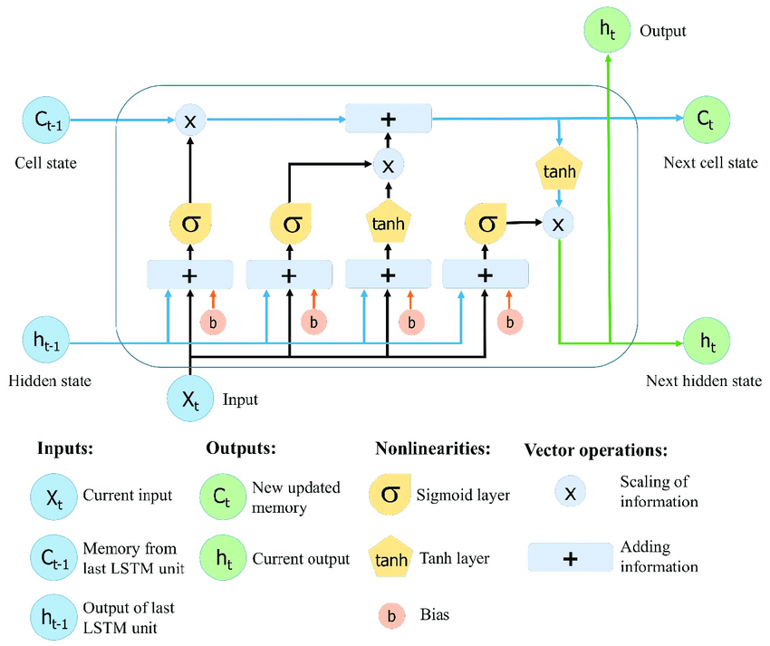
Fig 1.1 LSTM

  - BI-DIRECTIONAL LSTM(Bi-LSTM)
A Bidirectional LSTM (BiLSTM) extends the LSTM by processing text in both forward and backward directions, capturing context from both past and future words.
Forward Layer: Processes the sequence left to right.
Backward Layer: Processes the sequence right to left, capturing following context.
For hate speech detection, BiLSTM is valuable because it captures the full context. For example, in “They are ruining everything 😤,” a BiLSTM understands both the negative sentiment and how the emoji enhances the meaning, improving detection of subtle hate speech patterns.
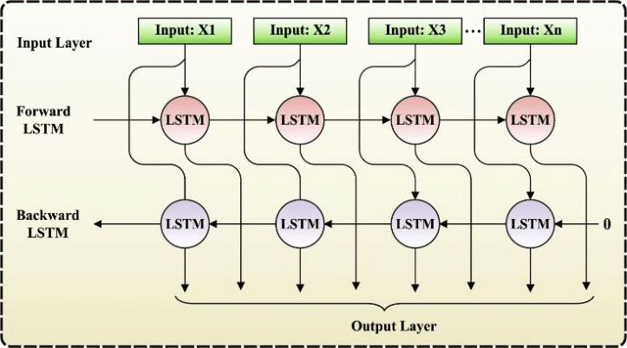
Fig 1.2 Bi-LSTM

  - DB SCAN CLUSTERING
DBSCAN (Density-Based Spatial Clustering of Applications with Noise) is a clustering algorithm that groups data points based on their density, making it particularly effective for datasets with irregularly shaped clusters and noise. The algorithm relies on two parameters: epsilon (ε), which defines the maximum distance between two points for them to be considered neighbors, and MinPts, the minimum number of points required to form a dense cluster. DBSCAN classifies points as core points (those with at least MinPts neighbors), border points (close to a core point but with fewer than MinPts neighbors), or noise (outliers not part of any cluster). It begins by selecting a random point and checking its neighborhood. If it’s a core point, a cluster is formed, and all reachable points are added to the cluster. The algorithm iteratively expands clusters and identifies noise points. In hate speech detection, DBSCAN can cluster tweets or texts based on features like sentiment scores, word embeddings, or emoji patterns, separating hateful content from non-hateful while effectively handling ambiguous or noisy data.
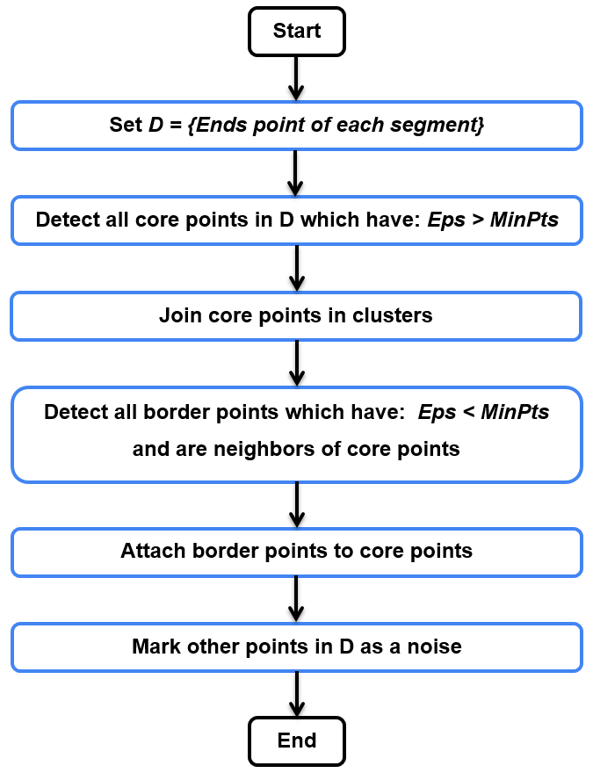
Fig 1.3 DB Scan Clustering

  - ATTENTION MECHANISM
The attention mechanism enhances sequence models by enabling them to focus on the most relevant parts of the input while processing, making it essential in modern NLP models like Transformers. It operates by using three components: Query (Q), representing the information being processed; Key (K), representing features of all input elements; and Value (V), containing the actual information to pass forward. The mechanism computes similarity scores (e.g., dot product) between the Query and Keys, applies a softmax function to normalize these scores into probabilities, and uses these probabilities to weight the Values. This process allows the model to prioritize important parts of the sequence over less relevant ones. For example, in hate speech detection, an attention mechanism can focus on critical components of a tweet, such as keywords (e.g., "deserve," "ban") and emojis (e.g., 🛑), to better understand hateful intent. By emphasizing key elements, attention improves the model’s ability to capture subtle patterns and relationships in the data, even in long or complex sequences.

  - PROBLEM STATEMENT
Hate speech on social media poses significant societal risks, especially during global events like the Paris 2024 Olympics, where multilingual and context-dependent communication is prevalent. Traditional detection systems struggle with integrating textual and non-textual features like emojis and nuanced semantics.
This project aims to develop a context-aware tweet classification model using LSTM, Bi-LSTM, DB Scan clustering, and attention mechanisms to improve hate speech detection accuracy.

  - OBJECTIVES
This project focuses on developing a context-aware hate speech detection system for tweets related to the Paris 2024 Olympics. The approach involves preprocessing and cleaning data, associating emojis with text for semantic understanding, and labelling tweets as Hate or Non-Hate. Feature extraction methods include GloVe embeddings, emoji embeddings, and N-grams, followed by implementing LSTM and Bi-LSTM models. Enhanced models incorporate feature extraction with DB Scan clustering and adding attention mechanisms to improve classification accuracy and better capture the nuances of textual and non-textual features. The system is evaluated using metrics like precision, recall, F1-score, and accuracy to ensure robust performance.
  - ABOUT THE PROJECT
This project, titled " Context-Aware Tweets Classification Using LSTM and Bi-LSTM", aims to design a robust system to identify hate speech on Twitter, with a focus on the Paris 2024 Olympics dataset. The project consists of three main modules.
- Pre-processing and Feature Extraction
The first module focuses on preparing the dataset for analysis. Preprocessing includes:
- Removing unwanted elements such as URLs, special characters, punctuation, and stop words.
- Tokenization and lemmatization to normalize text.
- Associating emojis with unique words to capture their contextual meaning.
- Labeling data into Hate and Non-Hate categories, giving higher weight to emoji-based predictions.
Feature extraction techniques applied in this module include:
Word Embeddings (GloVe): Generates dense vector representations of words, capturing semantic relationships and contextual meanings.
Emoji Embeddings: Encodes emoji features, enabling the model to understand their sentiment and context.
N-grams: Utilizes Uni-grams (one-word sequences), bi-grams (two-word sequences), Tri-grams (three-word sequences) to capture local dependencies and improve text representation.
- LSTM and Bi-LSTM
This module involves building and experimenting with deep learning architectures:
The core of the project lies in the Modeling module, which implements both LSTM and Bi-LSTM architectures for tweet classification. LSTM, a type of recurrent neural network, is particularly effective for sequence prediction tasks, and Bi-LSTM extends this by capturing information from both directions of the sequence. With both feature extraction word embedding (GloVe) and N-grams (Bi-grams) of Top 10 and 5000 Bi-grams.

- LSTM and Bi-LSTM with DB Scan and Attention Mechanism
The next module is implementation of LSTM and Bi-LSTM with feature extraction of Word Embedding (GloVe) and N-grams (Bi-grams) with application of clustering techniques like DB Scan and Attention Mechanism to enhance the model’s ability to focus on the most relevant for accurate classification.
  - ORGANIZATION OF THE REPORT
The project report is structured as follows: Chapter 1, Introduction, provides an overview of the domain, outlining the project objectives and the report’s organization. Chapter 2, Literature Survey, reviews existing methodologies and challenges in hate speech detection, emphasizing the role of transfer learning and neural networks in addressing these challenges, along with the importance of emoji embeddings and N-gram analysis for improving model performance. Chapter 3, System Design, details the architectural framework, explaining the design and integration of components like preprocessing, feature extraction, and model implementation. Chapter 4, Implementation, covers the technical aspects of module integration, including the setup of machine learning pipelines, data flow management, and model deployment for evaluation. Chapter 5, Results and Discussion, presents the evaluation metrics, experimental results, and a comparison of the model’s performance with existing solutions. Finally, Chapter 6, Conclusion and Future Work, summarizes the project’s contributions, discusses limitations, and proposes directions for future research and potential applications.
  - SUMMARY
This chapter highlights the project, which focuses on hate speech detection in tweets related to the Paris 2024 Olympics, addressing challenges posed by the integration of text and emojis. It highlights the need for a context-aware classification system using LSTM, Bi-LSTM, DB Scan clustering, and attention mechanisms. The objectives include data preprocessing, feature extraction (GloVe embeddings, emoji embeddings, and N-grams), and deep learning-based classification. The project is organized into three modules: preprocessing and feature extraction, LSTM/Bi-LSTM modelling, and enhanced techniques for improved accuracy. An overview of the report's structure is provided, covering the methodology, results, and future directions.

CHAPTER 2
LITERATURE SURVEY
The studies on hate speech and offensive content detection employ various methodologies and datasets to address different aspects of the problem.
2.1 RELATED WORK ON MACHINE LEARNING
Among ML approaches, Nobata et al. (2016) [21] used handcrafted features like N-grams and linguistic cues combined with Support Vector Machines (SVM), achieving an accuracy of 78% on online user content. Similarly, Burnap and Williams (2015) [10] implemented statistical modeling with ML classifiers on Twitter data, reporting 80% accuracy, benefiting from computational efficiency but limited generalizability.
Barath Kumar V et al. (2023) [7] developed a machine learning model for human emotion detection, translating recognized emotions into corresponding emojis. They used a dataset comprising images with labeled emotions to train their model, achieving high accuracy in emotion recognition. The approach enhances user interaction by automating emoji suggestions but may encounter limitations in accurately interpreting complex or subtle human emotions.
Meanwhile, Chrismanto et al. (2023) [11] enhanced ML by integrating ensemble methods with emoji features and post-comment pairs, achieving 85% accuracy on social media data. Although ML methods are lightweight and interpretable, they heavily depend on manual feature extraction, which struggles with nuanced or multilingual content.
2.2 RELATED WORK ON DEEP LEARNING
On the other hand, deep learning (DL) approaches, such as Baziotis et al. (2017) [8], applied LSTM with Attention Mechanism and GloVe embeddings on the SemEval-2017 dataset, achieving 88% accuracy by effectively capturing contextual and sequential relationships. Mozafari et al. (2020) [20] adopted a BERT-based model, mitigating racial bias and achieving 92% accuracy, showcasing state-of-the-art performance on social media datasets but demanding high computational resources.
Alsafari et al. (2020) [4] implement a Deep Learning approach using LSTM and GloVe embeddings for Arabic hate speech detection. The dataset is collected from Arabic social media platforms. The model achieves an accuracy of 84%. LSTMs effectively capture sequential relationships and context in Arabic texts. The model requires high computational resources, and GloVe embeddings may miss out on new slang or emerging hate speech patterns.
Ahmed and Lin (2022) [1] proposed a hate speech detection method combining deep learning with active learning, focusing on attention network visualization for instance selection, transfer learning with hate speech lexicons, and synonym expansion. Their approach uses entropy-based active learning cycles for iterative annotation and training, emphasizing explainability and data efficiency. However, reliance on specific lexicons and increased computational complexity may limit generalizability.
In [6], Badiya et al. (2017) employed deep learning techniques to detect hate speech in tweets, utilizing a dataset of Twitter posts labeled for hate speech. Their model achieved notable accuracy, demonstrating the effectiveness of deep learning in this context. However, the study faced challenges such as the need for large labeled datasets and potential biases in data representation.
Aluru et al. (2020) [5] studied multilingual hate speech detection using LASER embeddings with logistic regression for low-resource languages and BERT-based models for high-resource settings. They demonstrated promising zero-shot classification results for languages like Italian and Portuguese. Their analysis, based on a nine-language, 16-source dataset, highlighted dependency on data availability but provided robust baselines and a public framework for future research.
Similarly, Adine Nayla et al. (2023) [1] used the BERT algorithm on Twitter data, reporting 90% accuracy, while Dalavi et al. (2024) [12] combined Bi-LSTM with GloVe embeddings for emoji-based classification, achieving 89% accuracy by integrating textual and emoji features effectively. Another hybrid approach by Sifak and Setiawan (2023) [24] employed CNN-BiGRU with Attention Mechanism, attaining 87% accuracy on Twitter data.
Roy et al. (2024) [25] proposed an LSTM-based approach for real-time hateful sentiment detection in tweets. Utilizing a dataset of tweets labeled for sentiment, their model achieved competitive accuracy, enabling timely identification of hateful content. The real-time capability is advantageous for monitoring social media, but the model may require continuous updates to adapt to evolving language patterns and slang. Sifak and Setiawan (2023) [27] implemented a hate speech detection system using a combination of Convolutional Neural Networks (CNN) and Bidirectional Gated Recurrent Units (BiGRU) with an attention mechanism on Twitter data. Their model, trained on a dataset of tweets labeled for hate speech, achieved high accuracy, benefiting from the attention mechanism's focus on relevant parts of the text. While effective, the model's performance may be influenced by the quality and representativeness of the training data.
These DL models, particularly transformer-based methods, excel in accuracy and robustness across complex, multilingual datasets but require substantial training time and computational power.
2.3 RELATED WORK ON TRADITIONAL APPROACHES
In contrast, traditional approaches rely on simpler linguistic features. Warner and Hirschberg (2012) [31] used N-grams and manual feature extraction for hate speech detection, achieving 75% accuracy but lacking scalability for large datasets. Similarly, Purver and Battersby (2012) [23] experimented with emoticons for sentiment detection in dialogue, reaching 72% accuracy but showing limitations for hate speech classification.
Al-Hassan and Al-Dossari (2019) [3] focus on multilingual hate speech detection using traditional ML techniques like Naïve Bayes and Support Vector Machines (SVMs). They use a multilingual corpus comprising texts in Arabic, English, and other languages. The reported accuracy is 76%. Efficient for multilingual scenarios and computationally lightweight. Limited performance in detecting complex hate speech, especially in short-text or emoji-heavy posts.
Malmasi and Zampieri (2017) [18] apply traditional ML approaches like SVM with character N-grams and word embeddings for hate speech detection. The study uses a social media dataset and achieves an accuracy of 78%. Simple and effective for small datasets, with interpretable features. It struggles with capturing deep semantic relationships and subtle hate speech patterns.
While traditional methods are lightweight and interpretable, they perform poorly compared to ML and DL approaches. Overall, deep learning methods dominate in terms of performance, with accuracies ranging from 87% to 92%, due to their ability to leverage contextual embeddings and hybrid architectures. However, the computational requirements and dependency on large annotated datasets remain key challenges, whereas ML and traditional methods offer simplicity at the cost of lower accuracy and generalizability.
2.4 RELATED WORKS ON OTHER APPROACHES
Here, are the different approaches that are used in papers, Felbo et al. (2017) [13] propose a novel method for emoji-based sentiment and hate speech detection using deep learning embeddings derived from millions of emoji occurrences. The dataset includes massive social media text (multi-domain data), achieving an accuracy of 86%. The model generalizes well across domains and learns robust representations from emoji usage. Dependency on emoji data might reduce performance for text-only inputs. Bölücü and Canbay (2021) [9] utilize Graph Convolutional Networks (GCNs) to detect hate and offensive speech in social media data. They use a customized dataset annotated for graph-based structures. The accuracy achieved is 83%. GCNs effectively model relationships between words and users, capturing contextual nuances. Requires complex preprocessing and is computationally expensive for large-scale graphs.
Goh and Kulathuramaiyer (2020) [14] introduced an emoji messaging system grounded in indigenous cultural values, adopting a socio-technical innovation approach. Their methodology involved integrating cultural insights into emoji design to facilitate more meaningful digital communication. While the system was well-received for cultural relevance, its applicability might be limited to specific cultural groups, potentially reducing its universality. Gupta et al. [15] proposed a hand gesture recognition system aimed at predicting emojis based on recognized gestures. Utilizing a dataset of hand gesture images mapped to specific emojis, their model achieved satisfactory accuracy in real-time applications. This system offers an intuitive method for emoji input but may struggle with distinguishing similar gestures or adapting to individual user variations.
King and Sutton (2013) [16] examined the temporal clustering of hate-motivated offenses, analyzing crime data to identify patterns in hate crime occurrences. Their findings indicated significant temporal clusters, suggesting that certain periods are more prone to such offenses. While providing valuable insights for law enforcement, the study's reliance on reported incidents may overlook unreported cases, affecting the comprehensiveness of the data. Mandl et al. (2021) [17] presented an overview of the HASOC subtrack at FIRE 2021, focusing on hate speech and offensive content identification in English and Indo-Aryan languages. They compiled a multilingual dataset and evaluated various models' performance, contributing to the development of robust hate speech detection systems. However, challenges such as language nuances and dialectal variations posed difficulties in achieving consistent accuracy across all languages.
Mishra et al. (2021) [19] explored multi-task, multi-lingual learning using transformer models for identifying hate and offensive speech on social media. Their approach leveraged shared representations across tasks and languages, utilizing diverse datasets to enhance model performance. The model demonstrated improved accuracy in detecting offensive content across multiple languages but required substantial computational resources and large datasets for optimal performance.
Praveen et al. [22] developed an emoji creation system based on facial emotion detection using Convolutional Neural Networks (CNNs). By training on a dataset of facial images labeled with corresponding emotions, their model could generate appropriate emojis reflecting user expressions. The system achieved high accuracy in emotion detection, enhancing user experience in digital communications. However, it may face challenges in accurately interpreting ambiguous or mixed facial expressions. Sharif et al. (2024) [26] introduced a novel model fusion approach to enhance hate speech detection, leveraging a comprehensive dataset. Their methodology combined multiple models to improve detection accuracy, addressing the complexities of hate speech in digital platforms. The fused model outperformed individual models, offering a robust solution for content moderation. However, the increased complexity may lead to higher computational costs and potential challenges in model interpretability.
Srivastava et al. (2021) [28] developed an emotion recognition-based emoji retrieval system using deep learning. By training on a dataset of text inputs labeled with emotions, their model could suggest appropriate emojis corresponding to the detected emotions. The system enhanced user engagement by providing contextually relevant emojis but might face challenges in accurately interpreting complex emotional expressions in text. Suttles and Ide (2013) [29] investigated emoticon-based detection of sarcasm on Twitter. Analyzing a dataset of tweets containing emoticons, they developed a model to identify sarcastic content, achieving moderate accuracy. The study highlighted the potential of using emoticons as indicators of sarcasm but also noted limitations due to the subtlety and context-dependence of sarcastic expressions.
Tandyonomanu (2018) [30] examined the representation of nonverbal symbols, specifically emojis, in communication technology. The study discussed how emojis serve as proxies for nonverbal cues in digital communication, enhancing message clarity and emotional expression. While emojis enrich text-based interactions, their interpretation can be subjective, potentially leading to misunderstandings.
This paper highlights the selected papers present diverse methodologies ranging from traditional ML models like SVMs and Naïve Bayes to advanced Deep Learning models like LSTMs, GCNs, and Transformers. Emoji-based methods ([13], [22]) highlight innovative approaches integrating contextual features and emojis. Hybrid fusion approaches like [26] strike a balance by combining ML and DL models, achieving high accuracies of up to 90%. Traditional models, while interpretable and resource-efficient, struggle with deep contextual understanding, whereas DL and hybrid models perform well but require significant computational power and large annotated datasets.
2.5 CHALLENGES
- Complexity of Context Understanding:
Tweets often have nuanced and indirect expressions of hate speech that are difficult to classify without context-aware mechanisms.
- Imbalanced Dataset:
Hate speech datasets often have an imbalanced distribution, with fewer hate speech samples compared to non-hate ones, which can affect model performance.
- Dimensionality and Feature Overlap:
Combining GloVe embeddings, emoji embeddings, and N-grams can lead to high-dimensional feature spaces, requiring careful optimization to avoid overfitting.
- Effectiveness of Clustering:
DB Scan clustering's performance depends heavily on selecting appropriate hyperparameters (e.g., epsilon and minimum points), which might vary across datasets.
- Scalability:
Ensuring the model's scalability and efficiency when processing large datasets or real-time streams of tweets.

2.6 SUMMARY
This chapter highlights existing methodologies and challenges in hate speech detection, focusing on the role of natural language processing (NLP) and deep learning techniques. It highlights traditional approaches like keyword-based detection and machine learning models, which struggle to capture contextual nuances, especially in multilingual and emoji-rich datasets. Recent advancements, such as GloVe embeddings, and neural networks like LSTM and Bi-LSTM, have improved performance by capturing semantic and sequential relationships in text. The integration of features like emoji embeddings and N-grams has been identified as crucial for handling implicit and explicit hate speech. It also shows the challenges that are faced during the project.

CHAPTER 3
SYSTEM DESIGN
This Chapter focuses on Architecture of our model with their overview and dataset description.
3.1 SYSTEM ARCHITECTURE
The Structured overview of the System Architecture of Hate Speech Detection using Transfer Learning.
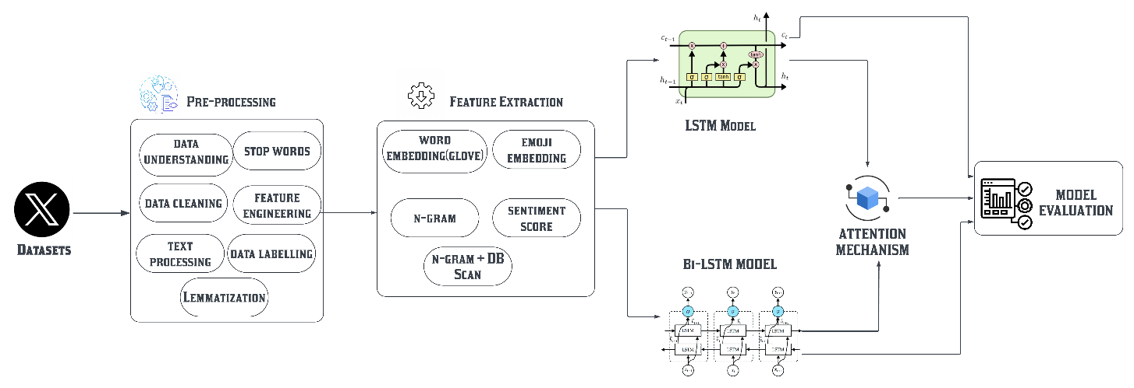
Fig 3.1 System Architecture
The figure 3.1 a comprehensive framework for hate speech detection in tweets using advanced deep learning techniques, including LSTM and Bi-LSTM models, integrated with clustering and attention mechanisms. The architecture is divided into several key modules, each playing a critical role in the overall process, starting from raw data preprocessing to final model.
- Modules Overview: The system processes tweets through preprocessing, feature extraction, model training, and evaluation. Each stage refines the raw data to enable accurate hate speech classification.
- Preprocessing:
  - Data Understanding: Explore data structure and quality.
  - Data Cleaning: Remove noise (special characters, URLs, etc.).
  - Text Processing: Tokenization and lemmatization.
  - Stop Words Removal: Remove common, unimportant words.
  - Feature Engineering: Create features like emoji-text associations.
  - Data Labelling: Classify tweets into "Hate" and "Non-Hate" categories.
- Feature Extraction:
- Word Embedding (GloVe): Convert words into vector representations.
- Emoji Embedding: Encode emoji sentiment.
- N-Grams: Capture sequential word relationships.
- Sentiment Score: Determine overall tweet sentiment.
- N-Gram + DB Scan: Cluster similar words/tweets.
- LSTM Model: Use LSTM to process the sequence of words and emojis to detect hate speech patterns.
- Bi-LSTM Model: Process sequences in both forward and backward directions for better contextual understanding.
- Attention Mechanism: Focus on important words/emoji to improve model accuracy.
7. Model Evaluation: Evaluate the model using metrics like accuracy, precision, recall, and F1-score to assess performance.
3.2 DATASET DESCRIPTION
The system starts by collecting tweets and other relevant textual data from online sources, which may include social media platforms, forums, or public datasets. The collected data is initially unlabelled and consists of both text and emoji content related to the Paris 2024 Olympics. Since the data is initially unlabelled, it undergoes a manual or semi-automated labelling process to classify it as either "Hate Speech" or "Non-Hate Speech.". The figure 3.2 shows a dataset that has 31,542 entries with 15 attributes, focusing on tweets related to the Paris 2024 Olympics.
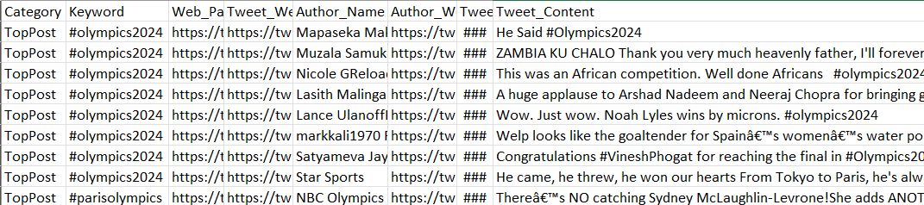
Fig 3.2 Olympics twitter tweets Datasets
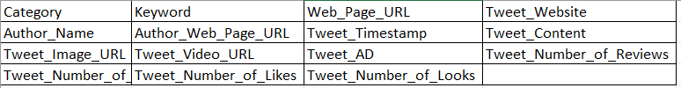
Fig 3.3 Dataset Attributes
The figure 3.3 shows an attribute of an Olympics datasets. Below is an explanation of each attribute and its potential role in your hate speech detection project:
- Category: This likely represents the type of tweet, such as "Top Post". It is not essential for labelling tweets, which will be used in training your model to classify tweets correctly.
- Keyword: This attribute could contain specific keywords or phrases related to Context dataset like “#olympics2024”, “#OlympicsParis”. Keywords help in identifying relevant content within tweets, enhancing the feature extraction process for model training.
- Web_Page_URL: This URL might direct to a webpage related to the tweet or author. It can be useful for identifying additional context about the tweet, though it might not be directly involved in hate speech detection unless context is needed.
- Author_Name: The name of the tweet's author. This could be useful for analyzing the user's history or behaviours in sentiment analysis but would typically be excluded from the final model unless you aim to include author-based features.
- Author_Web_Page_URL: A URL linking to the author's page. Similar to Author_Name, this can help build a user profile but is usually not a direct feature for hate speech detection.
- Tweet_Timestamp: The time the tweet was posted. Temporal information can sometimes influence sentiment, especially during sensitive events, and may be useful for contextualizing the tweet within specific time frames.
- Tweet_Content: The main body of the tweet. This is the most critical feature for your model, as it contains the text that will be processed for hate speech detection. This text will undergo preprocessing, tokenization, and embedding during feature extraction.
- Tweet_Image_URL: URL of any image attached to the tweet.
- Tweet_Video_URL: Similar to Tweet_Image_URL, this URL links to any video attached to the tweet.
- Tweet_AD: Indicates if the tweet is an advertisement. Ads might contain different language patterns compared to regular tweets and could be filtered out or treated separately in the analysis.
- Tweet_Number_of_Reviews: The number of reviews or responses to the tweet. The engagement level might be useful in understanding the reach or impact of the tweet, though it’s not directly related to hate speech detection.
- Tweet_Number_of_Likes: The number of likes the tweet has received. This can be a proxy for the tweet’s popularity or sentiment. Highly liked tweets could be analyzed for whether they contribute to or are involved in hate speech.
- Tweet_Number_of_Looks: The number of views or impressions the tweet has received. Similar to Tweet_Number_of_Likes, this can help gauge the spread of a tweet but isn’t directly tied to detecting hate speech unless you explore virality patterns.

3.3 SUMMARY
This chapter highlights the system architecture for hate speech detection in tweets includes preprocessing, feature extraction, model training, and evaluation. Preprocessing involves cleaning text, tokenization, lemmatization, stop word removal, and emoji-text association, followed by labelling data as "Hate" or "Non-Hate." Feature extraction uses GloVe word embeddings, emoji embeddings, N-grams, sentiment scores, and DB Scan clustering to capture patterns. LSTM and Bi-LSTM models process these features, with an Attention Mechanism prioritizing key words and emojis for improved accuracy. The system is evaluated using metrics like accuracy, precision, recall, and F1-score. The dataset includes attributes like Tweet_Content (main text), which are critical for model training. Features such as Keywords, Image/Video URLs, Likes, and Timestamps add context, while Author_Name and Web_Page_URL provide supplementary details. Together, these components ensure accurate and context-aware hate speech detection.

CHAPTER 4
SYSTEM DEVELOPMENT
This section outlines the stages of the system development, including the design and implementation of modules, dataset handling, model training and evaluation.
4.1 DATA PRE-PROCESSING AND FEATURE EXTRACTION
After collecting datasets, now we start with pre-processing and feature extraction. Preprocessing cleans and normalizes text by removing noise and ensuring consistency, while feature extraction transforms text into numerical representations. These steps help models focus on relevant patterns for accurate text classification.
4.1.1 DATA PRE-PROCESSING
To clean, pre-process and extract meaningful features from the input text data for model training.
- Data Understanding: This step involves analysing the collected dataset to understand its structure, including identifying the number of tweets, the diversity of languages, and the presence of emojis shown in figure 4.1.
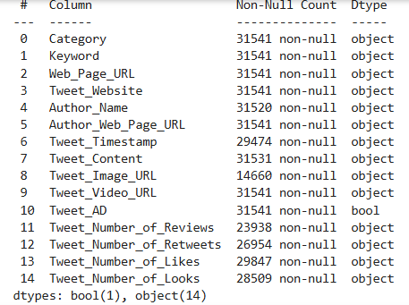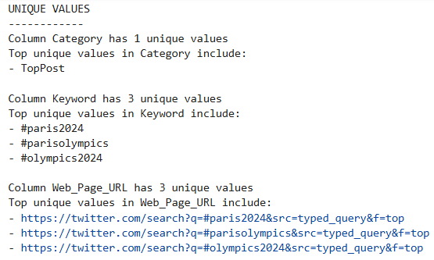
Fig 4.1 Data Understanding
- Data Cleaning: process of removing or correcting noisy, irrelevant, or inconsistent data to improve its quality and ensure accuracy for analysis or modelling.
- Removing Duplicates: Elimination of duplicate tweets to ensure the integrity of the dataset show in figure 4.2.
- Handling Missing Values: Addressing any missing data by either filling gaps or discarding incomplete entries show in figure 4.2.
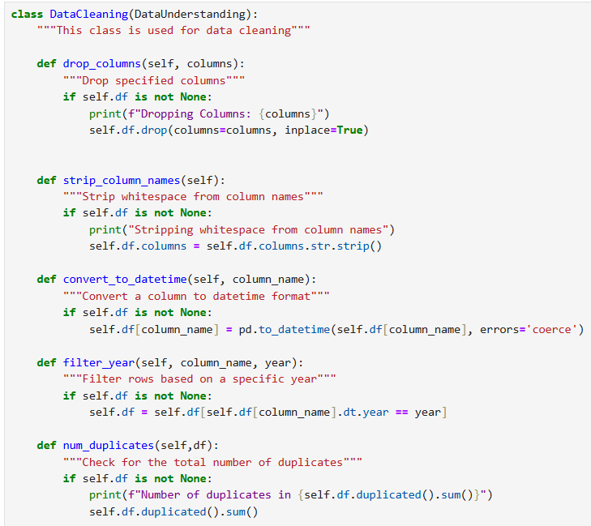
Fig 4.2 Data Cleaning
- Text Processing: Transforming raw text into a clean and structured format through steps like tokenization, normalization, and removing noise for further analysis.
- Removing ASCII characters: Stripping out any non-ASCII characters to maintain uniformity shown in figure 4.3.
- Replacing Emojis: Converting emojis to their textual equivalents to facilitate analysis show in figure 4.3.
- Lemmatization: Reducing words to their base forms to standardize variations of words show in figure 4.3.
- Stop Words Removal: Filtering out common words that do not contribute to the meaning of the text shown in figure 4.3.
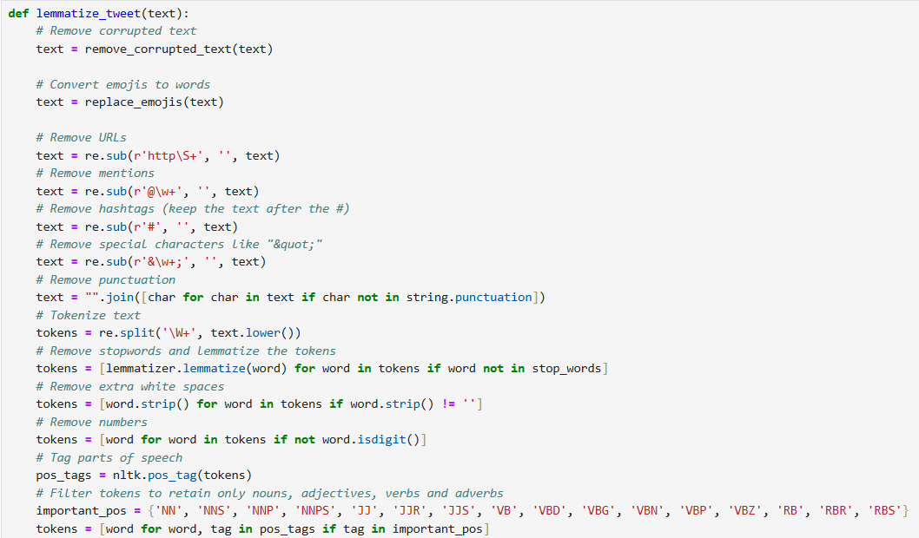
Fig 4.3 Lemmatization
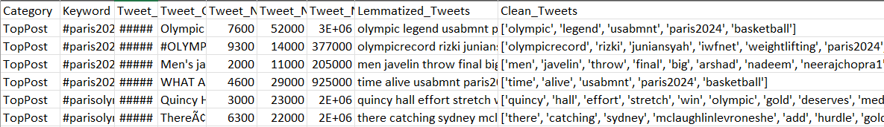
Fig 4.4 Cleaned Tweets
- Feature Engineering:
- Adding Emojis to Unique Words: Enhancing the dataset by associating relevant emojis with unique words, which aids in context understanding shown in figure 4.5.
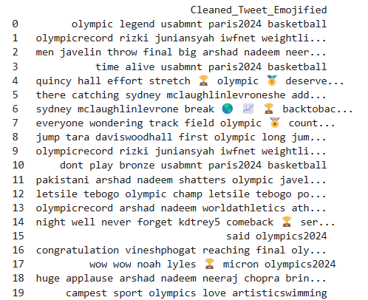
Fig 4.5 Emoji Added
  - Data Labelling: Manually or semi-automatically label each tweet or text sample as "Hate Speech" or "Non-Hate Speech" shown in figure 4.6.
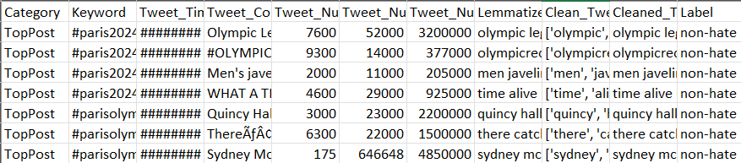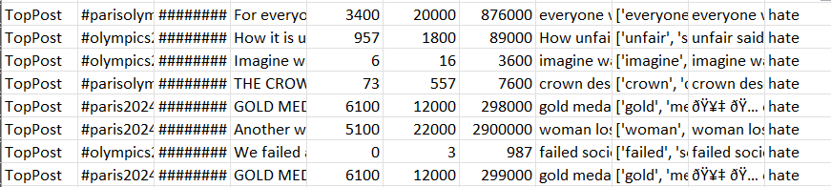
Fig 4.6 Data Labelling
4.1.2 FEATURE EXTRACTION
In this project, we implemented a range of feature extraction techniques to capture both text-based and emoji-based nuances in hate speech, considering the specific nature of social media language.
- Word Embeddings: Capture semantic information from the text in tweets, enabling the model to understand the context and meaning of words. We utilized pre-trained GloVe embeddings to convert each word in a tweet into a dense vector representation. Each tweet was tokenized, and individual word vectors were averaged to form a single vector, representing the semantic context of the entire tweet. GloVe embeddings allow for a compact representation of textual data, improving model interpretability by understanding word meanings and relationships shown in figure 4.7.
- N-grams: Identify common word pairs (bigrams) that could indicate hate speech when used in specific combinations. Using the CountVectorizer from Scikit-Learn, we extracted N-grams from the text, creating a feature matrix where each column represented a unique N-gram. This feature is especially useful for capturing frequently used hate expressions or sentiments in phrases. The use of N-grams allows the model to capture multi-word expressions that may not be apparent when analyzing individual words, improving accuracy in detecting specific hate speech phrases shown in figure 4.7. Here we are using Bi-grams, where it will be represented by frequency that are shown in figure 4.8.
- Sentiment Scores: Measure the overall sentiment of each tweet, as hate speech is often correlated with negative sentiment. TextBlob was used to calculate a sentiment polarity score for each tweet, where the score ranges from -1 (negative) to 1 (positive). This feature serves as an indicator of the emotional tone in tweets. Including sentiment scores helps the model distinguish between neutral or positive messages and those that carry negativity, which could indicate hate speech shown in figure 4.7.
- Emoji Embeddings: Capture the emotional tone and context conveyed through emojis, which are commonly used in tweets to amplify sentiment. Emojis were identified using the emoji library and converted to descriptive text. GloVe embeddings were then used to obtain vector representations of these emojis. Similar to word embeddings, we averaged emoji embeddings to create a single vector for each tweet. Emojis often substitute for words in informal communication, carrying significant emotional content. Representing them as embeddings improves the model’s understanding of non-verbal cues in hate speech shown in figure 4.7.
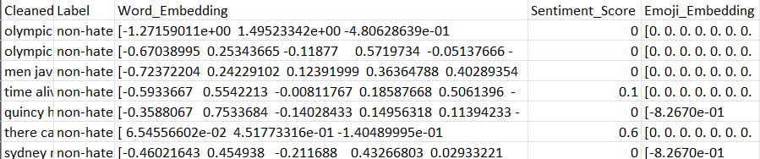
Fig 4.7 Feature Extraction
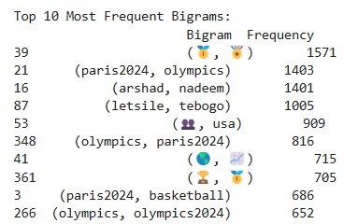
Fig 4.8 Top 10 Bi-grams
4.2 LSTM AND BI-LSTM MODELS
To build and train deep learning models to detect hate speech using LSTM and Bi-LSTM model.
4.2.1 LSTM MODEL
To build a LSTM model with Word Embedding (GLoVe) and N-grams(Bi-grams) features.
- With Word Embedding (GloVe): The embeddings provide dense, pre-trained word representations as input to LSTM, which processes sequential data by capturing long-term dependencies and contextual relationships for tasks like text classification.
Input:
- A DataFrame “tweets_df” with the following columns:
- Word_Embedding: List of embeddings representing the tweets.
- Label: Text labels (e.g., 'Hate' or 'Non-Hate').
- Parameters for the LSTM model:
- Number of epochs = 20.
- Batch size = 32.
- Learning rate = 0.001.
- Test split = 20% of the data.
Process:
- Data Preparation:
- Convert Word_Embedding into a 2D NumPy array X.
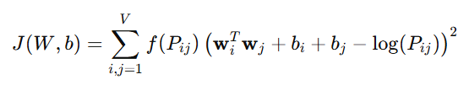…. (Eq 4.1)
- Encode Label using LabelEncoder and apply one-hot encoding to get y_categorical.
- Split the data into training and testing sets (X_train, X_test, y_train, y_test).
- Data Reshaping:
Reshape X_train and X_test to include a single timestep for LSTM compatibility.
- Model Definition:
- Build an LSTM model with: An LSTM layer (64 units),
- Dropout layers (0.5),
- Dense layers (32 units with ReLU, output layer with 2 units and softmax).
- Compile the model using Adam optimizer, binary cross-entropy loss, and accuracy metric.
- Model Training:
- Train the model on the training data with 20 epochs and batch size 32.
- Validate on the testing data during training.
- Model Evaluation:
- Evaluate the model on the testing set to get test loss and accuracy.
- Predict class labels for the test data.
- Generate performance metrics (confusion matrix and classification report).
Output:
Final test accuracy of the model, predicted classes for the testing dataset, Confusion matrix comparing true and predicted labels, Classification report with detailed performance metrics (precision, recall, F1-score).
- With N-grams (Bi-Grams): It represent sequences of adjacent words, and when used with LSTM, they help capture local word patterns and contextual relationships in text, enhancing sequential learning for tasks like classification.
Input:
- Dataset (tweets_df):
- Bigrams_with_Emojis: A list of bigrams (with emojis) for each tweet.
- Label: The target label for classification (e.g., 'Hate' or 'Non-Hate').
- Parameters:
- Top 10 and 5000 bigrams selection for feature extraction.
- LSTM Model hyperparameters:
- Epochs = 20.
- Batch size = 32.
- Learning rate = 0.001.
Process:
- Extract Features:
- Identify the top 10 and 5000 most frequent bigrams from Bigrams_with_Emojis.
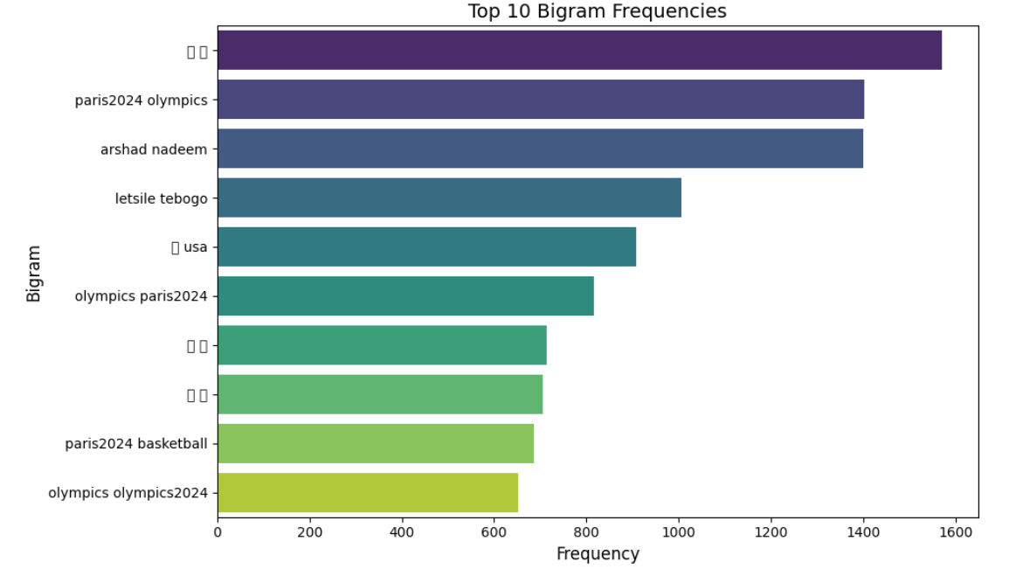
Fig 4.9 Bi-grams Top 10 with Frequency
- Create a feature vector for each tweet, representing the count of these bigrams.
- Prepare Data:
- Encode the target labels (Label) into one-hot format.
- Split the dataset into training (80%) and testing (20%) subsets.
- Build and Train Model:
- Reshape feature vectors for LSTM compatibility.
- Define an LSTM model with:
- 64 LSTM units,
- Dropout layers (0.5 rate),
- Dense layers (32 units with ReLU and softmax output for binary classification).
- Train the model on the training set and validate on the test set.
- Evaluate Model:
- Calculate test accuracy.
- Generate predictions for the test data and compute performance metrics (confusion matrix and classification report).
Output:
Final test accuracy of the model, predicted classes for the testing dataset, Confusion matrix comparing true and predicted labels, Classification report with detailed performance metrics (precision, recall, F1-score).
4.2.2 Bi-LSTM MODEL
To build a LSTM model with Word Embedding (GLoVe) and N-gram (Bi-gram) features.
- With Word Embedding (GloVe): This provides dense, pre-trained word vectors that serve as input to Bi-LSTM, enabling the model to capture both past and future context in text for more accurate sequence predictions.
Input:
- Dataset (tweets_df):
- Word_Embedding: A 2D array representing word embeddings of tweets.
- Label: The target label for classification (e.g., 'Hate' or 'Non-Hate').
- Parameters:
- Bidirectional LSTM with 64 units.
- Dropout rate = 0.5.
- Dense layer with 32 units and ReLU activation.
- Learning rate = 0.001.
- Epochs = 20, Batch size = 32.

Process:
- Prepare Data:
- Convert Word_Embedding to a NumPy array (X) and one-hot encode labels (y).
- Split into train (80%) and test (20%) sets, reshaping data for LSTM.
- Define and Train Model:
- Build a Bidirectional LSTM model with 64 units, dropout, and 2 output neurons.
- Compile and train the model for 20 epochs.
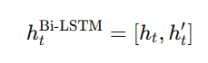…… (Eq 4.2)
- Evaluate and Metrics:
- Evaluate model accuracy and generate predictions.
- Output confusion matrix and classification report (precision, recall, F1-score).
Output:
Final test accuracy of the model, predicted classes for the testing dataset, Confusion matrix comparing true and predicted labels, Classification report with detailed performance metrics (precision, recall, F1-score).
- With N-grams (Bi-grams): N-grams (Bi-grams) capture adjacent word pairs, and when combined with Bi-LSTM, they enable the model to learn both past and future word dependencies for improved sequence prediction and classification.
Input:
- Dataset (tweets_df):
- Bigrams_with_Emojis: A list of bigrams (with emojis) for each tweet.
- Label: Target label for binary classification (e.g., 'Hate' or 'Non-Hate').
- Parameters:
- Bidirectional LSTM with 64 units.
- Dropout rate = 0.5.
- Dense layer with 32 units and ReLU activation.
- Learning rate = 0.001.
- Epochs = 20, Batch size = 32.
Process:
- Feature Extraction:
Extract top 10 or 5000 bigrams and create feature vectors for each tweet.
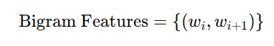
- Data Preparation:
Encode and one-hot encode labels, then split data into training and test sets.
- Data Reshaping:
Reshape data to fit the LSTM input format.
- Model Definition:
Define a Bidirectional LSTM with dropout and dense layers.
- Model Training:
Compile and train the model for 20 epochs.
- Model Evaluation:
Evaluate the model on the test set and generate predictions.
- Performance Metrics:
Compute confusion matrix and print classification report (precision, recall, F1-score).

Output:
Final test accuracy of the model, predicted classes for the testing dataset, Confusion matrix comparing true and predicted labels, Classification report with detailed performance metrics (precision, recall, F1-score).
  - LSTM AND Bi-LSTM MODEL WITH DB SCAN CLUSTERING AND ATTENTION MECHANISM
To build and train deep learning models to detect hate speech using LSTM and Bi-LSTM model with DB Scan clustering adding to the feature extraction and Attention mechanism to the model.
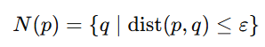 ….. (Eq 4.3)
    - LSTM MODEL (WITH DB SCAN CLUSTERING AND ATTENTION MECHANISM)
To build a LSTM model with DB scan clustering into feature extraction and adding attention mechanism to model with word embedding (GloVe) and N-grams (Bi-grams) features.
- With Word Embedding (GloVe): This feature combined with DBSCAN cluster features enhance LSTM with attention mechanisms by providing dense semantic representations and clustering-based insights, improving contextual understanding and pattern recognition.
Input:
Tweets dataset (tweets_df) containing:
- Clean_Tweets: Tokenized tweets.
- Word_Embedding: Precomputed word embeddings for each tweet.
- Label: Target labels for classification (e.g., hate or non-hate).
- Emojis (hate_emojis, non_hate_emojis): List of hate and non-hate emojis.

Process:
- Add Emoji Features: Create binary columns for the presence of hate and non-hate emojis in tweets.
- Combine Features: Merge word embeddings with emoji features into a single feature matrix.
- DBSCAN Clustering: Apply DBSCAN on the combined features to group similar instances.
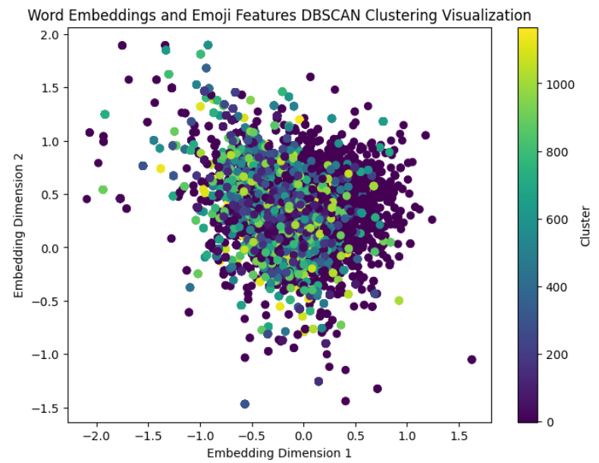
Fig 4.10 LSTM Word Embedding Clustering
- Reshape Labels: Adjust the DBSCAN cluster labels for LSTM input compatibility.
- Label Encoding: Convert target labels to categorical format for classification.
- Train-Test Split: Split the data into training and testing sets.
- Model Definition: Build an LSTM model with Attention for sequence processing.
- Model Training: Train the model using the Adam optimizer and categorical crossentropy.
- Model Evaluation: Evaluate the model's performance on the test data.
- Performance Metrics: Generate accuracy, confusion matrix, and classification report.
Output:
Clustering visualization (scatter plot) showing DBSCAN results on the first two embedding dimensions, Print the model's test accuracy as a percentage, Display confusion matrix and classification report.
- With N-grams (Bi-grams): This feature combined with DBSCAN clustering provide sequential context and density-based insights, enhancing LSTM with attention mechanisms for improved pattern recognition and contextual understanding in text data.
Input:
Tweets Data (tweets_df):
- Contains a column 'Bigrams_with_Emojis' representing tokenized bigrams (pairs of words) along with emojis.
- Contains a 'Label' column indicating the label ('hate' or 'non-hate') for each tweet.
Process:
- Extract Top 10 or 5000 Bigrams: Get the most frequent 10 or 5000 bigrams from the Bigrams_with_Emojis column.
- Create Feature Vectors: Create feature vectors by counting occurrences of each bigram in the tweet.
- DBSCAN Clustering: Perform DBSCAN clustering and append cluster labels to the feature matrix.
- Prepare Labels: Encode the 'hate' or 'non-hate' labels to categorical format.
- Train-Test Split: Split data into training and test sets.
- LSTM Model with Attention: Define and train an LSTM model with attention for binary classification.
- Model Evaluation: Evaluate the model using accuracy, confusion matrix, and classification report.
Output:
Test accuracy of the model (percentage), Confusion matrix showing True Positives, True Negatives, False Positives, and False Negatives, Classification report with precision, recall, and F1-score for both classes ('hate' and 'non-hate').
    - BI-LSTM MODEL (WITH DB SCAN CLUSTERING AND ATTENTION MECHANISM)
To build a Bi-LSTM model with DB scan clustering into feature extraction and adding attention mechanism to model with word embedding (GloVe) and N-grams (Bi-grams) features.
- With Word Embedding (GloVe): This feature combined with DBSCAN clustering provide semantic representations and density-based insights, enhancing Bi-LSTM with attention mechanisms for improved contextual learning and sequence modeling.
Input:
Tweets dataset (tweets_df) containing:
- Clean_Tweets: Tokenized tweets.
- Word_Embedding: Precomputed word embeddings for each tweet.
- Label: Target labels for classification (e.g., hate or non-hate).
- Emojis (hate_emojis, non_hate_emojis): List of hate and non-hate emojis.

Process:
- Add Emoji Features: Extract and add features for hate and non-hate emojis in the Clean_Tweets column.
- Prepare Word Embeddings: Convert word embeddings into a 2D numpy array and combine with emoji features.
- DBSCAN Clustering: Apply DBSCAN clustering on the combined embeddings and visualize the clustering.
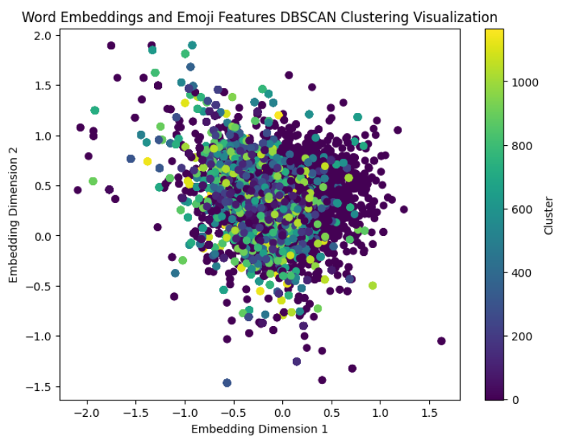
Fig 4.11 Bi-LSTM Word Embedding Clustering
- Prepare Labels: Encode the 'Label' column and prepare categorical labels.
- Train-Test Split: Split the data into training and testing sets.
- Bi-LSTM Model with Attention: Define and train a Bi-LSTM model with an attention mechanism.
- Evaluate the Model: Evaluate the model's accuracy, confusion matrix, and classification report.

Output:
Clustering visualization (scatter plot) showing DBSCAN results on the first two embedding dimensions, Print the model's test accuracy as a percentage, Display confusion matrix and classification report.
- With N-grams (Bi-grams): This feature combined with DBSCAN clustering capture local sequential patterns and density-based relationships, enhancing Bi-LSTM with attention mechanisms for better contextual and structural understanding of text data.
Input:
Tweets Data (tweets_df):
- Contains a column 'Bigrams_with_Emojis' representing tokenized bigrams (pairs of words) along with emojis.
- Contains a 'Label' column indicating the label ('hate' or 'non-hate') for each tweet.
Process:
- Extract Top 10 or 5000 Bigrams: Get the most frequent 10 or 5000 bigrams from the Bigrams_with_Emojis column.
- Create Feature Vectors: Create feature vectors by counting occurrences of each bigram in the tweet.
- DBSCAN Clustering: Perform DBSCAN clustering and append cluster labels to the feature matrix.
- Prepare Labels: Encode the 'hate' or 'non-hate' labels to categorical format.
- Train-Test Split: Split data into training and test sets.
- Bi-LSTM Model with Attention: Define and train a Bi-LSTM model with attention for binary classification.
- Model Evaluation: Evaluate the model using accuracy, confusion matrix, and classification report.
Output:
Test accuracy of the model, Confusion matrix showing True Positives, True Negatives, False Positives, and False Negatives, Classification report with precision, recall, and F1-score for both classes ('hate' and 'non-hate').
4.4 SUMMARY
The chapter highlight the development for hate speech detection consists of three modules. Pre-processing and Feature Extraction involves cleaning the Twitter dataset by removing white spaces, URLs, special characters, and stop words, followed by tokenization, lemmatization, and feature extraction using GloVe word embeddings, emoji embeddings and N-grams. LSTM and Bi-LSTM Models implement sequential models to classify text into hate and non-hate categories, improving contextual understanding. LSTM and Bi-LSTM Models implement sequential models with Attention Mechanisms and N-gram and DB Scan clustering to classify text into hate and non-hate categories, improving contextual understanding. Together, these modules transform raw text data into accurate predictions using advanced deep learning techniques.

CHAPTER 5
RESULTS AND DISCUSSION
  - HARWARE AND SOFTWARE REQUIREMENTS
System Requirements:
- Processor: Intel(R) Core (TM) i5-1335U.
- RAM: Minimum 8 GB (16 GB recommended for smoother performance, especially during Model training).
- Display: Minimum 1080p resolution for clear visualizations.
- Network Requirements:
- Internet Connection: Stable broadband connection for accessing cloud services, downloading datasets, and model Training and Testing.
- Local Network: LAN or Wi-Fi for testing multi-user access in a controlled environment.
Software Requirements:
- Programming Language: Python 3.x
- Development Environment:
- Jupyter Notebook: For interactive coding, experimentation, and visualization.
- Libraries and Frameworks:
- Pandas: For data manipulation, cleaning, and handling CSV files.
- NumPy: For numerical operations and efficient array manipulations.
- NLTK (Natural Language Toolkit): For stop word removal, tokenization, and basic text processing.
- Scikit-learn: For extracting n-grams (bi-grams).
- Custom Scripts: To create emoji embeddings and calculate sentiment scores for feature enrichment.
- TensorFlow/Keras:For building and training deep learning models such as LSTM and Bi-LSTM.
- Keras Layers Used
- Matplotlib and Seaborn: For visualizing model performance, loss curves, accuracy trends, and confusion matrices.
- GPU Utilization and Optimization:
- TensorFlow with CUDA/cuDNN: To enable GPU acceleration for faster model training and evaluation.
- TensorFlow Callbacks: To optimize training using techniques like EarlyStopping and ReduceLROnPlateau.

  - MODEL PERFORMANCE
The results from LSTM and Bi-LSTM shows distinct levels of performance, highlighting different aspects of model behavior, such as accuracy, precision, recall and the ability to generalize to unseen data. Below is the results and analysis of the LSTM and Bi-LSTM model.
5.2.1 LSTM
It shows result of LSTM model done in Word Embedding (GloVe) and N-grams (Bi-grams).
- Word Embedding (GloVe): Accuracy: 98.11%
Table 5.1 Classification Report LSTM (GloVe)
 | Precision | Recall | F1-score
0 (non-Hate) | 0.99 | 0.85 | 0.91
1(Hate) | 0.99 | 1.00 | 0.99

The figure 5.1 showcases the performance of the model with an overall accuracy of 98.11%. and the Table 5.1 shows Classification report Class 1 (Hate) has recall of 1.00, indicating the model identifies all instances of hate speech. The f1-score for both classes is high, with 0.99 for class 1 and 0.91 for class 0 (non-hate), showing a strong balance between precision and recall. The macro average f1-score of 0.95 confirms consistent performance across classes.
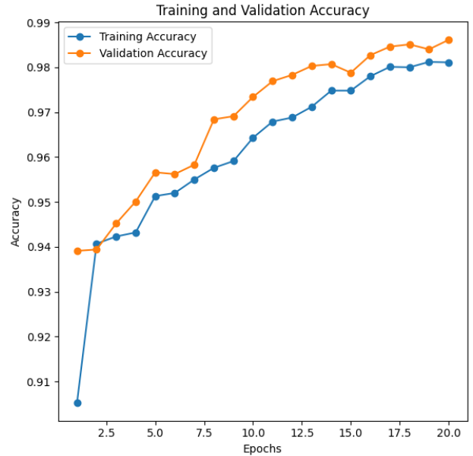
Fig 5.1 Training Accuracy of LSTM(GloVe)
- With N-grams (Bi-grams): Accuracy – 98.93%
Table 5.2 Classification Report – LSTM (Bi-grams)
 | Precision | Recall | F1-score
0 (non-Hate) | 1.00 | 0.79 | 0.88
1(Hate) | 0.99 | 1.00 | 0.99

The figure 5.2 demonstrates strong performance with a high accuracy of 98.93%. While table 5.2 shows classification report, for the non-Hate class, the precision is 1.00, recall is 0.79, and F1-score is 0.88, indicating good identification but some misclassification. The Hate class shows performance with precision at 0.99, recall at 1.00, and F1-score at 0.99, reflecting almost perfect identification.

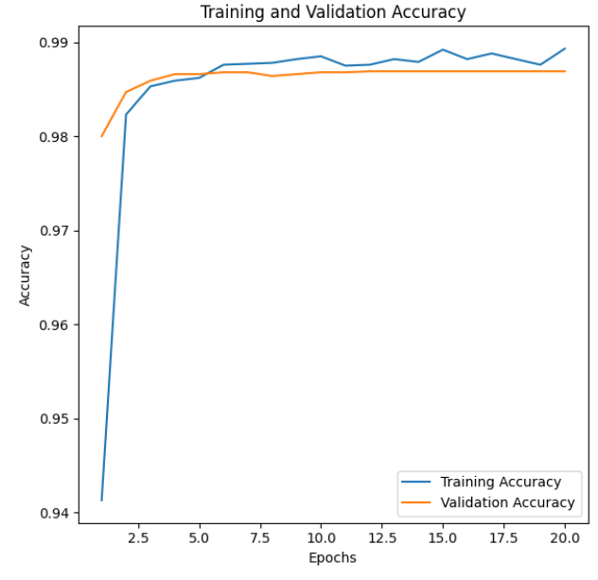
Fig 5.2 Training Accuracy LSTM (Bi-grams)
5.2.2 Bi-LSTM
It shows result of Bi-LSTM model done in Word Embedding (GloVe) and N-grams (Bi-grams).
- Word Embedding (GloVe): Accuracy: 98.47%
Table 5.3 Classification Report Bi-LSTM (GloVe)
 | Precision | Recall | F1-score
0 (non-Hate) | 0.98 | 0.80 | 0.88
1(Hate) | 0.99 | 1.00 | 0.99

The figure 5.3 shows model achieves a high accuracy of 98.47%, with strong performance across both classes. The table 5.3 shows a classification report, for the non-Hate class, the precision is 0.98, recall is 0.80, and F1-score is 0.88, indicating good performance but with some room for improvement in recall. The Hate class shows excellent precision at 0.99, perfect recall at 1.00, and an F1-score of 0.99, demonstrating near-perfect classification.
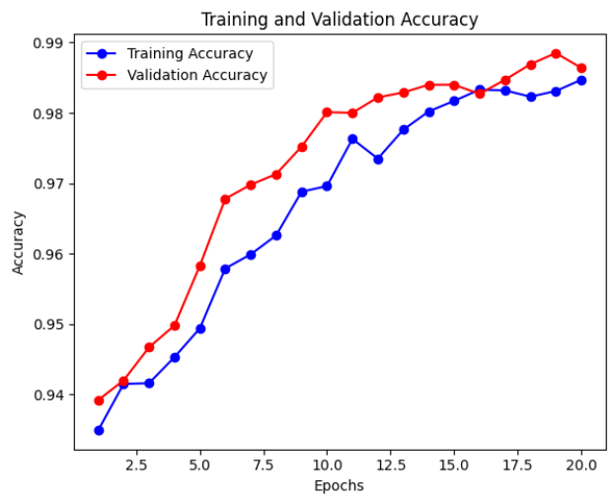
Fig 5.3 Training Accuracy of Bi-LSTM(GloVe)
- With N-grams (Bi-grams): Accuracy – 98.97%
Table 5.4 Classification Report – Bi-LSTM (Bi-grams)
 | Precision | Recall | F1-score
0 (non-Hate) | 1.00 | 0.79 | 0.88
1(Hate) | 0.99 | 1.00 | 0.99

The figure 5.4 shows an overall accuracy of 98.97%. The table 5.4 shows a classification report, For the non-hate class (0), the precision was 1.00, recall was 0.79, and the F1-score was 0.88, showing significant improvement in recall compared to the top-10 bi-grams. For the hate class (1), the precision was 0.99, recall was 1.00, and the F1-score was 0.99, indicating excellent performance. These results demonstrate that the model effectively classifies hate tweets while also improving recall for non-hate tweets.
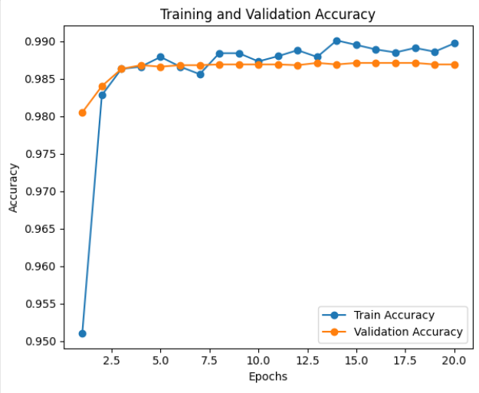
Fig 5.4 Training Accuracy Bi-LSTM (Bi-grams)
5.2.3 LSTM WITH DB SCAN AND ATTENTION MECHANISM
It shows result of LSTM model done in Word Embedding (GloVe) and N-grams (Bi-grams). Adding DB Scan clustering in feature extraction and attention mechanism in model.
a. Word Embedding (GloVe): Accuracy – 93.86%
Table 5.5 Classification Report LSTM (GloVe)
 | Precision | Recall | F1-score
0 (non-Hate) | 0.00 | 0.00 | 0.00
1(Hate) | 0.94 | 1.00 | 0.97

The figure 5.5 shows an overall accuracy of 93.86%. The Table 5.5 shows a classification report, for the non-hate class (0), both precision and recall were 0.00, resulting in an F1-score of 0.00, indicating the model failed to correctly identify non-hate tweets. In contrast, the hate class (1) achieved a precision of 0.94, recall of 1.00, and an F1-score of 0.97, showing excellent performance for hate tweet detection. These results suggest that while the model performs well for hate tweets, it struggles significantly with non-hate classification when using GloVe embeddings.
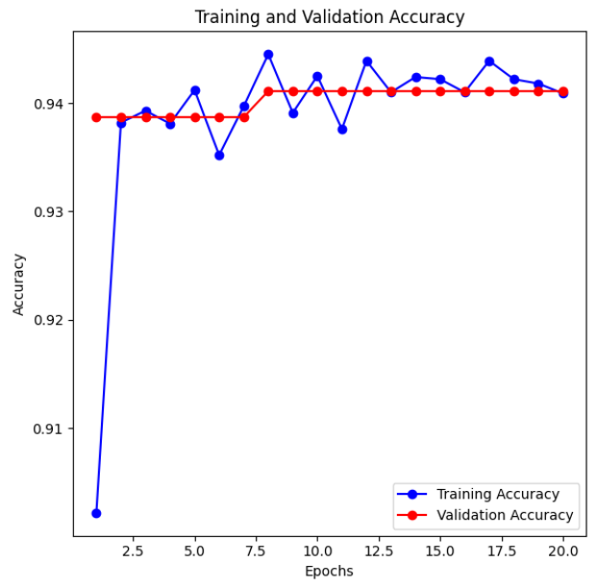
Fig 5.5 Training Accuracy LSTM (GloVe)
b. With N-grams (Bi-grams): Accuracy – 98.05%
Table 5.6 Classification Report – LSTM (Bi-grams)
 | Precision | Recall | F1-score
0 (non-Hate) | 0.99 | 0.69 | 0.82
1(Hate) | 0.98 | 1.00 | 0.99

The figure 5.6 shows an overall accuracy of 98.05%. The Table 5.6 shows a classification report, for the non-hate class (0), the precision improved to 0.99, recall increased to 0.69, and the F1-score reached 0.82, indicating better recognition of non-hate tweets compared to the top-10 bi-grams. The hate class (1) continued to perform exceptionally well, with a precision of 0.98, recall of 1.00, and an F1-score of 0.99. These results highlight that increasing the number of bi-gram features significantly improves the model's ability to balance performance across both classes.
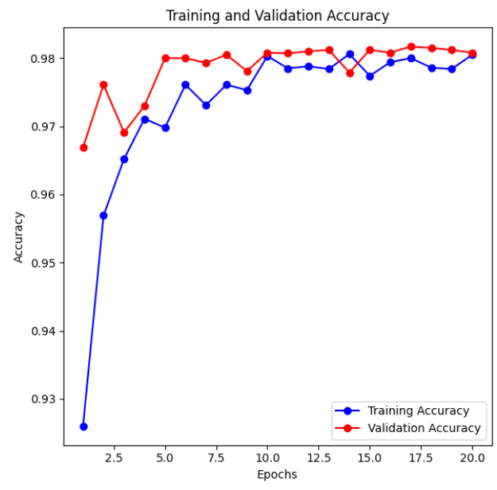
Fig 5.6 Training Accuracy LSTM (Bi-grams)
5.2.4 Bi-LSTM WITH DB SCAN AND ATTENTION MECHANISM
It shows result of Bi-LSTM model done in Word Embedding (GloVe) and N-grams (Bi-grams). Adding DB Scan clustering in feature extraction and attention mechanism in model.
a. Word Embedding (GloVe): Accuracy – 93.74%
Table 5.7 Classification Report – Bi-LSTM (GloVe)
 | Precision | Recall | F1-score
0 (non-Hate) | 0.00 | 0.00 | 0.00
1(Hate) | 0.94 | 1.00 | 0.97

The figure 5.7 shows an overall accuracy of 93.74%. The Table 5.7 shows a classification report, for the non-hate class (0), both precision and recall remained 0.00, resulting in an F1-score of 0.00, indicating the model completely failed to identify non-hate tweets. On the other hand, the hate class (1) showed strong performance with a precision of 0.94, recall of 1.00, and an F1-score of 0.97. These results suggest that while the Bi-LSTM effectively detects hate tweets, it struggles to classify non-hate tweets
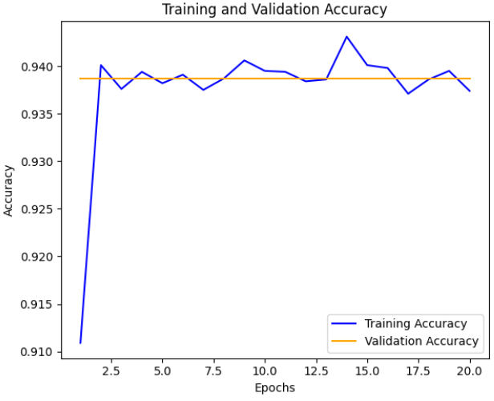
Fig 5.7 Training Accuracy Bi-LSTM (GloVe)
b. With N-grams (Bi-grams): Accuracy – 98.17%
Table 5.8 Classification Report – Bi-LSTM (Bi-grams)
 | Precision | Recall | F1-score
0 (non-Hate) | 0.98 | 0.70 | 0.81
1(Hate) | 0.98 | 1.00 | 0.99

The figure 5.8 shows an impressive overall accuracy of 98.17%. The table 5.8 shows a classification report, for the non-hate class (0), the precision was 0.98, recall improved significantly to 0.70, and the F1-score reached 0.81, indicating better detection of non-hate tweets compared to lower bi-gram frequencies. The hate class (1) maintained strong performance with a precision of 0.98, recall of 1.00, and an F1-score of 0.99. These results show that increasing the bi-gram features enhances the model's ability to balance predictions across both classes.
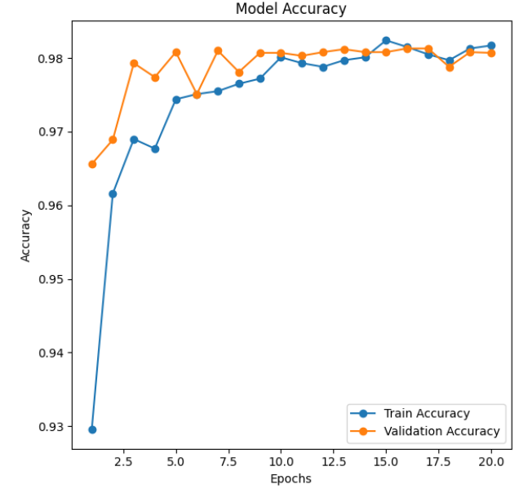
Fig 5.8 Training Accuracy Bi-LSTM (Bi-grams)

  - COMPARISON BETWEEN LSTM AND BI-LSTM WITH OR WITHOUT DB SCAN AND ATTENTION MECHANISM
This result shows comparison between LSTM and Bi-LSTM model with or without DB Scan Clustering and Attention Mechanism. The figure 5.9 shows the comparison between the models that are implemented. Each model differs from various colors.
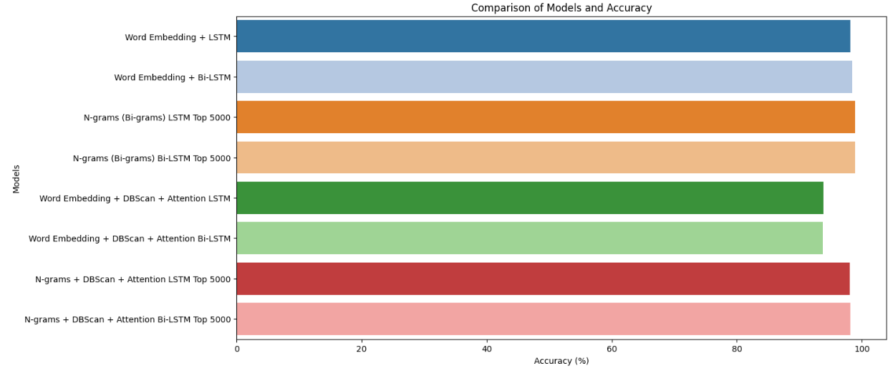
Fig 5.9 Visualization – Comparison of Model Implemented
Table 5.9 Comparison of Models Implemented
MODEL | ACCURACY
LSTM (GloVe) | 98.11%
LSTM (Bi-grams) | 98.93
Bi-LSTM(GloVe) | 98.47
Bi-LSTM(Bi-grams) | 98.97
LSTM + DB Scan+ Attention Mechanism (GloVe) | 93.86
LSTM + DB Scan+ Attention Mechanism (Bi-grams) | 98.05
Bi-LSTM + DB Scan+ Attention Mechanism (GloVe) | 93.74
Bi-LSTM + DB Scan+ Attention Mechanism (Bi-grams) | 98.17

5.4 SUMMARY
This chapter highlight the results of comparative performance of LSTM and Bi-LSTM models using various configurations. Bi-LSTM consistently demonstrates superior performance compared to LSTM due to its ability to leverage bidirectional contextual information.

CHAPTER 6
CONCLUSION AND FUTURE WORK
6.1 CONCLUSION
This project explored deep learning approaches for hate speech detection using the Olympics2024 dataset. Comparative experiments demonstrated that Bi-LSTM models consistently outperformed LSTM due to their ability to capture bidirectional dependencies. Word embeddings with Bi-LSTM achieved higher accuracy (98.47%) than LSTM (98.11%), while N-grams (Bi-grams) with the top 5000 features yielded the best performance: 98.97% for Bi-LSTM and 98.93% for LSTM. Introducing DBScan clustering and attention mechanisms resulted in slight performance degradation, with word embeddings delivering lower accuracy (93.86% for LSTM and 93.74% for Bi-LSTM). However, N-grams with clustering and attention retained strong performance, achieving 98.17% with Bi-LSTM. We also analyzed N-grams (Bi-grams) with the top 10 frequency, give 94.47%. Overall, larger N-gram features significantly contributed to improved model performance.
6.2 FUTURE WORK
Future research can extend this work in the following directions:
- Implement advanced architectures such as Transformers or Hybrid Models to improve performance and capture complex relationships in the data.
- By exploring other feature extraction like Linguistic feature such as syntactic dependencies, word frequencies, and topic modelling.
- Implementing Transfer Learning with pre-trained models like RoBERTa and GPT with fine-tuning on the dataset to handle complex hate speech patterns more effectively.
- Developing a real-time hate speech detection system to analyze social media content dynamically.

REFERENCES

- Adine Nayla; Casi Setianingsih; Burhanuddin Dirgantoro, 23 May 2023, “Hate Speech Detection on Twitter Using BERT Algorithm”, 2023 International Conference on Computer Science, Information Technology and Engineering (ICCoSITE), 10.1109/ICCoSITE57641.2023.10127831.

- Ahmed, U. and J. C.-W. Lin, 2022, "Deep explainable hate speech active learning on social-media data", IEEE Transactions on Computational Social Systems, Apr.

- Al-Hassan, A. and Al-Dossari, H. (2019). “Detection of hate speech in social networks: a survey on multilingual corpus.” In: 6th International Conference on Computer Science and Information Technology, vol. 10, pp. 10–5121. https:// doi. org/ 10. 5121/ csit. 2019. 90208.

- Alsafari, S., Sadaoui, S., Mouhoub, M. (2020). “Hate and offensive speech detection on Arabic social media”. Online Soc. Netw. Media, 19, 100096.

- Aluru, S. S., Mathew, B., Saha, P., Mukherjee, A, (2020), “Deep learning models for multilingual hate speech detection”, arXiv preprint arXiv:2004.06465.

- Badiya, P., Gupta, S., Gupta, M., Varma, V. (2017). “Deep learning for hate speech detection in tweets”. In: Proceedings of the 26th International Conference on World Wide Web Companion. pp. 759–760.

- Barath Kumar V; Sooryash J; Sriram B; Sushmita V; Sabitha B; Magudapathi P, 07 August 2023, “Human Emotion Detection to Emoji Display Using Machine Learning”, 2023 2nd International Conference on Advancements in Electrical, Electronics, Communication, Computing and Automation (ICAECA), 10.1109/ICAECA56562.2023.10201174.

- Baziotis, C., Pelekis, N., Doulkeridis, C. (2017). Datastories at SemEval-2017 Task 4: “Deep LSTM with Attention for Message-Level and Topic-Based Sentiment Analysis”, Proceedings of the 11th International Workshop on Semantic Evaluation (SemEval-2017), Association for Computational Linguistics, Vancouver, Canada, pp. 747–754.

- Bölücü, Necva and Pelin Canbay. (2021). “Hate Speech and Offensive Content Identification with Graph Convolutional Networks”.

- Burnap, P. and Williams, M. L. (2015). "Cyber hate speech on Twitter: An application of machine classification and statistical modeling for policy and decision making", Policy Internet, vol. 7, no. 2, pp. 223-242, Jun. 2015.
- Chrismanto, Antonius Rachmat; Anny Kartika Sari; Yohanes Suyanto, 2023, “Enhancing Spam Comment Detection on Social Media with Emoji Feature and Post-Comment Pairs Approach Using Ensemble Methods of Machine Learning”, IEEE Access (Volume: 11), 10.1109/ACCESS.2023.3299853, 28 July 2023.

- Dalavi, Sushil; Tanvesh Nivelkar; Sarvesh Patil; Aadesh Sawant; Pankaj Vanwari, 2024, “Enhancing Hate Speech Detection through Emoji-based Classification using Bi-LSTM and GloVe Embeddings”, 2023 6th International Conference on Advances in Science and Technology (ICAST), 10.1109/ICAST59062.2023.10455077, 04 March 2024.

- Felbo, B., Mislove, A., Søgaard, A., Rahwan, I., Lehmann, S. (2017). "Using millions of emoji occurrences to learn any-domain representations for detecting sentiment emotion and sarcasm", arXiv preprint arXiv:1708.00524.

- Goh, C. H., Kulathuramaiyer, N. (2020). "Developing an indigenous cultural values-based emoji messaging system: A socio-technical systems innovation approach", 12th ACM Conference on Web Science Companion, pp. 32-36, July 2020.

- Gupta, J., Goel, S., Varshney, S., Dhall, M. S., Gupta, M. N. “Hand Gesture Recognition for Emoji Prediction”.

- King, R. D., Sutton, G. M. (2013). "High times for hate crimes: Explaining the temporal clustering of hate-motivated offending", Criminology, vol. 51, pp. 871-894.

- Mandl, T., Modha, S., Shahi, G. K., Madhu, H., Satapara, S., Majumder, P., Schäfer, J., Ranasinghe, T., Zampieri, M., Nandini, D., Jaiswal, A. K. (2021). “Overview of the HASOC subtrack at FIRE 2021: Hate Speech and Offensive Content Identification in English and Indo-Aryan Languages”, Working Notes of FIRE 2021 - Forum for Information Retrieval Evaluation, CEUR, 2021.

- Malmasi, S. and Zampieri, M. (2017). “Detecting hate speech in social media”. In: Proceedings of the International Conference Recent Advances in Natural Language Processing, RANLP 2017, pp. 467–472.

- Mishra, S., Prasad, S., Mishra, S. (2021). "Exploring multi-task multi-lingual learning of transformer models for hate speech and offensive speech identification in social media", Social Netw. Comput. Sci., vol. 2, no. 2, pp. 1-19, Apr. 2021.

- Mozafari, M., Farahbakhsh, R., Crespi, N. (2020). "Hate speech detection and racial bias mitigation in social media based on BERT model", PLoS One, vol. 15, no. 8 August, pp. 1-26.

- Nobata, C., Tetreault, J., Thomas, A., Mehdad, Y., Chang, Y. (2016). “Abusive language detection in online user content” In: Proceedings of the 25th International Conference on World Wide Web, pp. 145–153.

- Praveen, T., Reddy, S. S., Reddy, T. V. K., Reddy, N. S., Chandrashekhar, S. N. “Emoji Creation with Facial Emotion Detection Using CNN”.

- Purver, M., Battersby, S. (2012). "Experimenting with emoticons in task-oriented dialogue", Proceedings of the 13th Annual Meeting of the Special Interest Group on Discourse and Dialogue, pp. 146-154.

- Qomarudin Sifak; Erwin Budi Setiawan, 2023, "Hate Speech Detection using CNN and BiGRU with Attention Mechanism on Twitter", 2023 IEEE International Conference on Communication, Networks and Satellite (COMNETSAT), DOI: 10.1109/COMNETSAT59769.2023.10420628.

- Roy, Sanjiban Sekhar; Akash Roy; Pijush Samui; Mostafa Gandomi; Amir H. Gandomi, 2024, "Hateful Sentiment Detection in Real-Time Tweets: An LSTM-Based Comparative Approach", IEEE Transactions on Computational Social Systems (Volume: 11, Issue: 4, August 2024), pp. 5028 - 5037, DOI: 10.1109/TCSS.2023.3260217.

- Sharif, Waqas; Abdullah, Saima; Iftikhar, Saman; Al-Madani, Daniah; Mumtaz, Shahzad. (2024). "Enhancing Hate Speech Detection in the Digital Age: A Novel Model Fusion Approach Leveraging a Comprehensive Dataset", IEEE Access (Volume: 12), DOI: 10.1109/ACCESS.2024.3367281.

- Sifak, Qomarudin; Erwin Budi Setiawan. (2023). "Hate Speech Detection using CNN and BiGRU with Attention Mechanism on Twitter", 2023 IEEE International Conference on Communication, Networks and Satellite (COMNETSAT), DOI: 10.1109/COMNETSAT59769.2023.10420628.

- Srivastava, S., Gupta, P., Kumar, P. (2021). "Emotion recognition-based emoji retrieval using deep learning", 2021 5th International Conference on Trends in Electronics and Informatics (ICOEI), pp. 1182-1186, June 2021.

- Suttles, J., Ide, N. (2013). "Emoticon-based detection of sarcasm in Twitter", Proceedings of the 2nd Workshop on Language in social media, pp. 1-10.

- D. Tandyonomanu, 2018, "Emoji: representations of nonverbal symbols in communication technology", IOP Conference series: materials science and engineering, vol. 288, no. 1, pp. 012052.

- W. Warner and J. Hirschberg, 2012, "Detecting hate speech on the world wide Web", Proc. 2nd Workshop Lang. social media, pp. 19-26, Jun. 2012.

